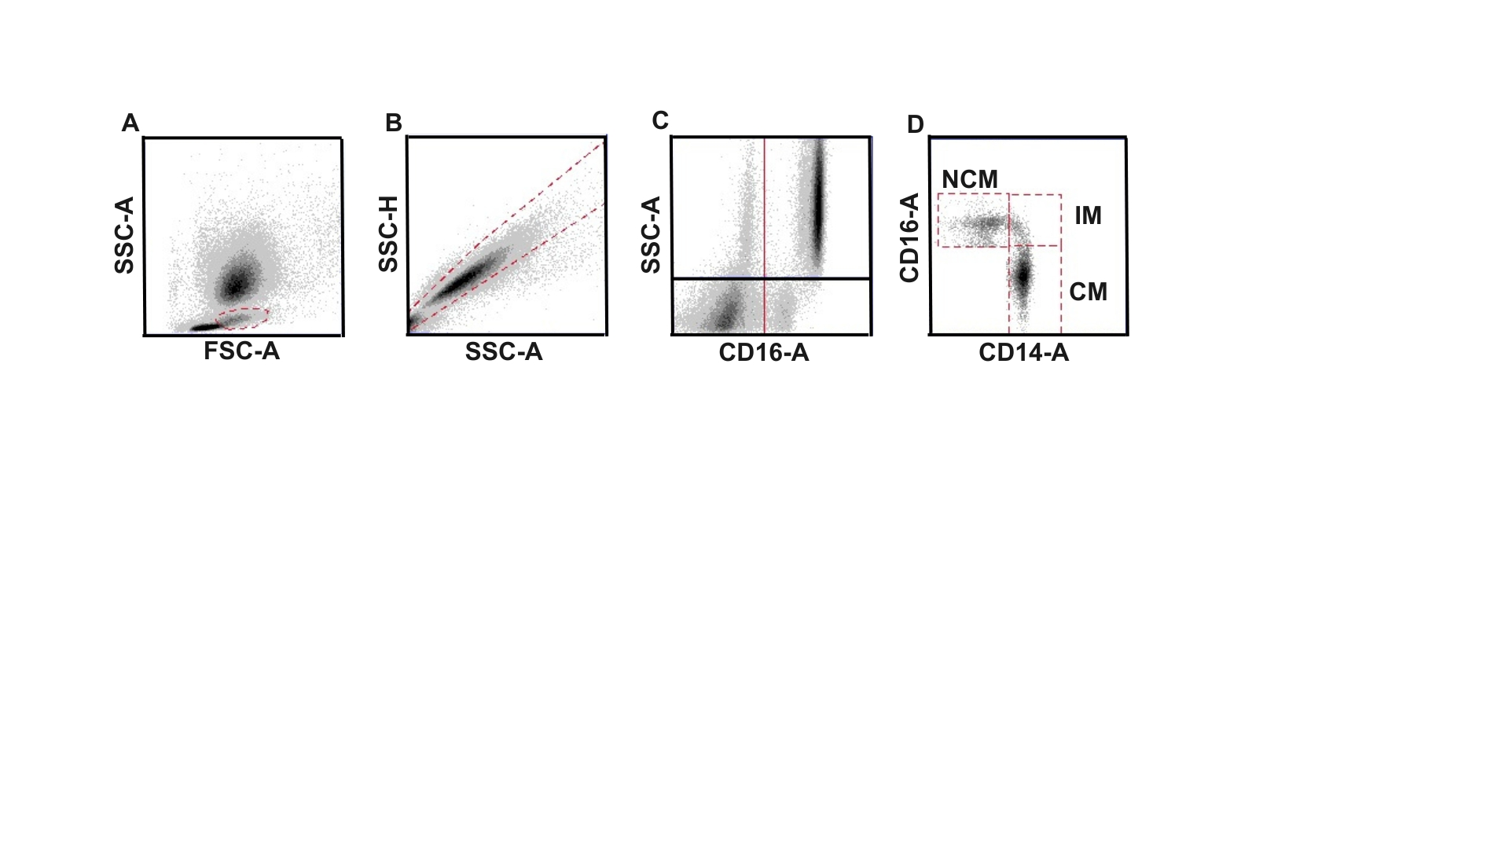

Supplementary Figure S1. Flow cytometry panel. A – monocytes were gated on using FSC-A vs SSC-A. B – doublets were excluded using SSC-A vs SSC-H. C – neutrophils were exluded using CD16-A vs SSC-A. Monocyte subsets were acquired by gating on monocytes, excluding doublets and neutrophils, then staining for CD14-FITC and CD16-PE. Compensation and positive regions were set using single stained controls. CM, classical monocytes; FSC-A, forward scatter area; IM, intermediate monocytes; NCM, non-classical monocytes; SSC-A, side scatter area; SSC-H, side scatter height.

